Aspect Term Extraction with History Attention and Selective Transformation

1 Introduction

Concretely, we propose a framework for more accurate aspect term extraction by exploiting the opinion summary and the aspect detection history. Firstly, we employ two standard Long-Short Term Memory Networks (LSTMs) for building the initial aspect and opinion representations recording the sequential information. To encode the historical information into the initial aspect representations at each time step, we propose truncated history attention to distill useful features from the most recent aspect predictions and generate the history-aware aspect representations. We also design a selective transformation network to obtain the opinion summary at each time step. Specifically, we apply the aspect information to transform the initial opinion representations and apply attention over the transformed representations to generate the opinion summary. Experimental results show that our framework can outperform state-of-the-art methods.

2 The Proposed Model

2.1 The ATE Task

2.2 Model Description

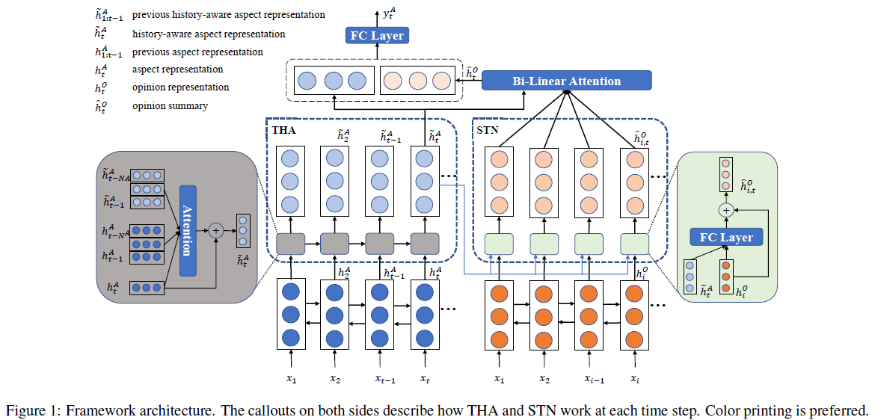

Building Memory

Capturing Aspect History

Capturing Opinion Summary

2.3 Joint Training

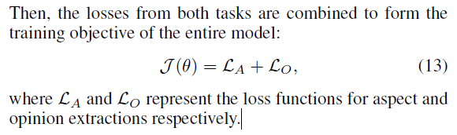

3 Experiment

3.1 Datasets

3.2 Comparisons

We compare our framework with the following methods:

3.3 Settings

3.4 Main Results

3.5 Ablation Study

3.6 Attention Visualization and Case Study

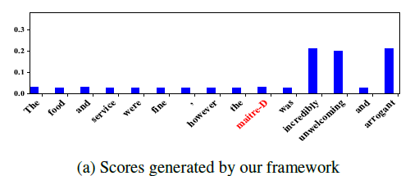

4 Related Work

5 Concluding Discussions

We design two components, i.e. truncated history attention, and selective transformation network.